Review of All Rights Protection Mechanisms (RPMs) in All gTLDs PDP Working Group - Phase 1 Initial Repot - Public Comment Input Form
This Public Comment forum seeks community feedback on the Phase 1 Initial Report published by the Review of All Rights Protection Mechanisms (RPMs) in All gTLDs Policy Development Process (PDP) Working Group.
* Required

1. Email address *

DRAFT NCSG Comments
Note: there are many questions below and it is not necessary to answer all of them.
NCSG can respond “No Opinion” or not answer to any question in the Google Doc.

>>> IMPORTANT INSTRUCTIONS >>> PLEASE READ BEFORE PROCEEDING >>>

Please submit your public comments via this form only
If you are unable to use Google forms, alternative arrangements can be made. Please contact policy- staff@icann.org for assistance.

You can review this entire form via its PDF and Word format
To facilitate off-line work, or for those who may not have access to the form, you can download a PDF or Word version of the form below:
- <INSERT PDF LINK>
- <INSERT WORD LINK>

There is no obligation to complete all sections within this form
Respond to as many or as few questions as desired. The only "mandatory" questions are those related to commenter's personal data in Section 1 and Section 2 of this form.

You may enter general comments in the last section (Section 11)
There is an opportunity to comment on the general content of this Initial Report and provide input that may not be tied to any specific items that the Working Group is seeking community input.

There is a limit of 2,000 characters (about 350-400 words) for each "comment box" question
In the event you reach the character limit, you may send an email to policy-staff@icann.org, and the Working Group
Support Staff will assist you and manually enter your responses.

To stop and save your work for later, you MUST (to avoid losing your work):
- Provide your email address above in order to receive a copy of your submitted responses;

- Click "Submit" at the end of the Google Form (the last question on every page allows you to quickly jump to the end of the Google Form to submit);

- After you click "Submit," you will receive an email to the above-provided email address; within the email, click the "Edit Response" button at top of the email;

- After you click the "Edit Response" button, you will be directed to the Google Form to return and complete;

- Repeat the above steps 2-4 every time you wish to quit the form and save your progress.

When the commenter hits the “Submit” button, all submitted comments will be displayed publicly via an automatically-generated Google Spreadsheet
Note: Email addresses provided by commenters will not be displayed.

The final date of the Public Comment forum is 23:59 UTC on 4 May 2020
This form will be closed by 23:59 UTC on 4 May 2020. Any comments received after that date/time will not be reviewed/discussed by the Working Group.

Other Important Instructions
- This is a standard format for collecting public comment. It seeks to:
-- Clearly link comments to specific sections of the Initial Report
-- Encourage commenters to provide reasoning or rationale for their opinions
-- Enable the sorting of comment so that the Working Group can more easily read all the comments on any one topic

- You can easily navigate from section to section in the form. There is a table of contents below so that you can “fast forward” to the desired section by hitting “next” at the bottom of each section.

- Since some of the preliminary recommendations and questions for community input are related, they are placed next to each other for easy reference. In addition, some of the questions for community input have been divided into multi-part questions so that feedback on these questions would be clear.

- Please click the link contained in the Google Form to read the details and context of each preliminary recommendation, community question, and individual proposal.

- Your comments should take into account scope of the PDP Working Group Phase 1 work as described by the Charter.

- It is important that your comments include rationale. The Working Group is interested in your reasoning so that the conclusions reached and the issues discussed by the team can be tested against the reasoning of others. This is much more helpful than comments that simply “agree” or “disagree”.

- Where applicable, you are encouraged to reference sections in the report for ease of the future review by the Working Group.

Table of Contents
Section 1: Email Address, Important Instructions, Table of Contents Section 2: Consent & Authorization
Section 3: URS Preliminary Recommendations & Community Questions Section 4: TMCH Preliminary Recommendation
Section 5: Sunrise Service Preliminary Recommendations & Community Questions

Section 6: Trademark Claims Service Preliminary Recommendations & Community Questions Section 7: TM-PDDRP Preliminary Recommendation
Section 8: URS Individual Proposals (Non-Recommendations) Section 9: TMCH Individual Proposals (Non-Recommendations) Section 10: Overarching Charter Questions
Section 11: Other Comments & Submission

By submitting my personal data, I agree that my personal data will be processed in accordance with the ICANN Privacy Policy ( https://www.icann.org/privacy/policy), and agree to abide by the website Terms of Service
(https://www.icann.org/privacy/tos).

Section 2: Consent & Authorization

- Please provide your name: *

Name (this will be public)

- Please provide your affiliation *

Noncommercial Stakeholders Group

- Are you providing input on behalf of another group (e.g., organization, company, government)? *
Mark only one oval.

Yes No
X

- If yes, please explain:

Save Your Progress

- Do you want to save your progress and quit for now? You will be able to return to the form to complete at a later time.
Mark only one oval.

Yes
No, I would like to continue to the next section

Section 3: URS Preliminary Recommendations & Community Questions

- This section seeks to obtain input on all the preliminary recommendations and questions related to the Uniform Rapid Suspension System (URS).

- Related URS preliminary recommendations and questions are placed next to each other for easy reference.

URS Recommendation #1
Please find the link to this Recommendation and its context here: h ttps://community.icann.org/x/byCJBw Note: URS Recommendation #1 has an associated URS Question #1 below.
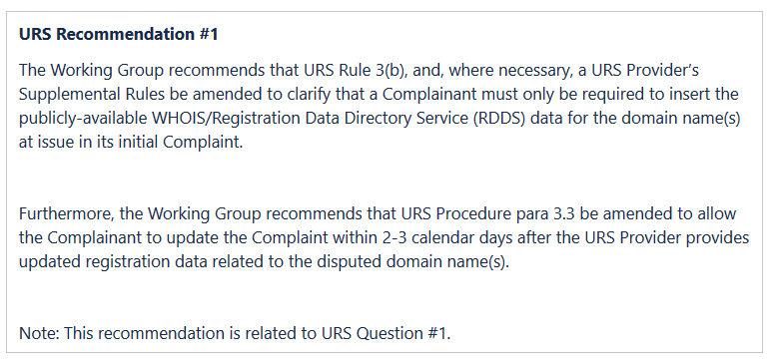

- Please choose one of the following responses for URS Recommendation #1:

Mark only one oval.

Support Recommendation as written
Support Recommendation concept with minor change Significant change required
Do not support recommendation Do not support Recommendation No opinion

- If you wish to (a) propose changes to URS Recommendation #1; and/or (b) provide a rationale for your response, please do so here.

This policy change would allow the trademark owner to amend the Complaint with registrant data which was redacted for privacy reasons (including GDPR and proxy registrations). Although the rationale of the working group was to allow trademark owners to identify registrants who have engaged in a pattern of bad faith registrations, the wording of this recommendation is in no way tied to this goal.

Since the URS is a low-cost, low-overhead proceeding, the processes are streamlined by The Forum (the largest of the URS providers). If the trademark owner amends its complaint, that data will be published with the decision absent any further interference.

According an individual’s name, or an organization’s location, may be disclosed despite the protection of this data under the personal and sensitive data protections of the GDRP and completely in violation of these protections and privacy rights. Further, the data would be disclosed even if the respondent wins.

Such disclosure – without regard to the “purpose” for which the PII is being obtained and disclosed – is a violation of privacy laws and principles. Any disclosure recommendation must be much more closely tied to the goal of disclosing those with a pattern of proven bad faith registrations.
Making nondisclosure contingent on action by the registrant is insufficient because the vast majority of URS cases do not generate a response from registrants, who may not understand that a default will expose their personal information.

URS Question #1
Please find the link to this Question and its context here: https://community.icann.org/x/cCaJBw Note: URS Question #1 is related to URS Recommendation #1.

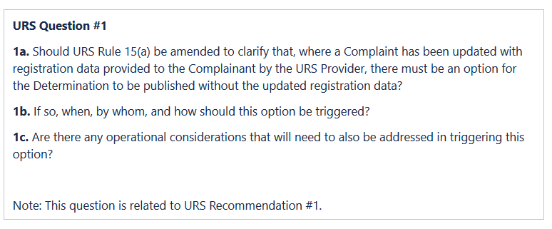
- URS Q1a. Should URS Rule 15(a) be amended to clarify that, where a Complaint has been updated with registration data provided to the Complainant by the URS Provider, there must be an option for the Determination to be published without the updated registration data?

Mark only one oval.

Yes No
No opinion
Other:

- URS Q1b. If so, when, by whom, and how should this option be triggered?

As above, the disclosure of redacted and private data of individual, organizations and businesses must be done only to further the “purpose” presented in the Working Group – helping disclose those with a pattern of proven bad faith registrations. Absent such a showing, the registrant data should be published as shown in the public WHOIS/RDDS (as it is today).
Making nondisclosure contingent on action by the registrant is insufficient because the vast majority of URS cases do not generate a response from registrants, who may not understand that a default will expose their personal information.

- URS Q1c. Are there any operational considerations that will need to also be addressed in triggering this option?

Yes, once the complaint is amended, the redacted and private information is published. Such publication must not be automatic (and legally may not be). Publication must only take place when a) the Complainant wins, b) and the grounds include a pattern of bad faith registrations. Even there, there may be compelling reasons for the protected data not to be published, and the Respondent must be able to provide it. Any procedure must take into account that many respondents default, and that there may be language difficulties involved. In no event must the publication of redacted data be automatic and unreviewed – that would be a violation of law and private rights.

URS Recommendation #2
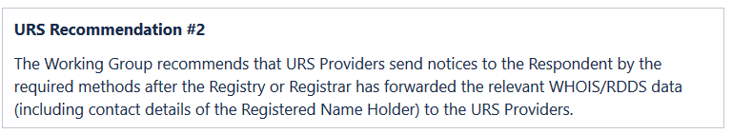
Please find the link to this Recommendation and its context here: h ttps://community.icann.org/x/hCGJBw

- Please choose one of the following responses for URS Recommendation #2:

Mark only one oval.

Support Recommendation as written
Support Recommendation concept with minor change Significant change required
Do not support Recommendation No opinion

- If you wish to (a) propose changes to URS Recommendation #2; and/or (b) provide a rationale for your response, please do so here.

URS Recommendation #3
Please find the link to this Recommendation and its context here: https://community.icann.org/x/hiGJBw

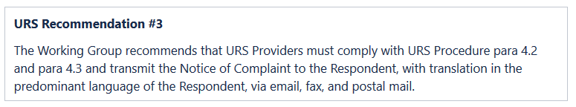

- Please choose one of the following responses for URS Recommendation #3:

Mark only one oval.

Support Recommendation as written
Support Recommendation concept with minor change Significant change required
Do not support Recommendation No opinion

- If you wish to (a) propose changes to URS Recommendation #3; and/or (b) provide a rationale for your response, please do so here.

This is a very important recommendation as the Registrant must be sent notice by all of these means in hopes that one reaches them.

URS Recommendation #4
Please find the link to this Recommendation and its context here: h ttps://community.icann.org/x/XyCJBw Note: URS Recommendation #4 has an associated URS Question #2 below.

URS Recommendation #4 (shortened)
The Working Group recommends that the ICANN org establishes a compliance mechanism to ensure that URS Providers, Registries, and Registrars operate in accordance with the URS rules and requirements and fulfill their role and obligations in the URS process.

- Please choose one of the following responses for URS Recommendation #4:

Mark only one oval.

Support Recommendation as written
Support Recommendation concept with minor change Significant change required
Do not support Recommendation No opinion

- If you wish to (a) propose changes to URS Recommendation #4; and/or (b) provide a rationale for your response, please do so here.

URS Question #2
Please find the link to this Question and its context here: https://community.icann.org/x/XyCJBw Note: URS Question #2 is related to URS Recommendation #4.

- URS Q2a. What compliance issues have Registries and Registrars discovered in URS processes, if any?

- URS Q2b. Do you have suggestions for how to enhance compliance of URS Providers, Registries, and Registrars in the URS process?

URS Recommendation #5
Please find the link to this Recommendation and its context here: h ttps://community.icann.org/x/cSCJBw Note: URS Recommendation #5 has an associated URS Question #3 below.
URS Recommendation #5
The Working Group recommends that the ICANN org, Registries, Registrars, and URS Providers keep each other’s contact details up to date in order to effectively fulfill the notice requirements set forth in the URS Procedure para 4.

- Please choose one of the following responses for URS Recommendation #5:

Mark only one oval.

Support Recommendation as written
Support Recommendation concept with minor change Significant change required
Do not support Recommendation No opinion

- If you wish to (a) propose changes to URS Recommendation #5; and/or (b) provide a rationale for your response, please do so here.

URS Question #3
Please find the link to this Question and its context here: https://community.icann.org/x/cSCJBw

(No reply needed – largely appropriate for Registries/Registrars)

Note:
- The Working Group recommends that public comment be sought from Registry Operators.
- URS Question #3 is related to URS Recommendation #5

- URS Q3a. Question to Registry Operators -- Have Registry Operator experienced any issues with respect to receiving notices from URS Providers?
Mark only one oval.

Yes No
Not sure
Other:
- URS Q3b. Question to Registry Operators -- Were these notices sent through appropriate channels?
Mark only one oval.

Yes No
Not sure
Other:

- URS Q3c. Question to Registry Operators -- Did the notices contain the correct information?
Mark only one oval.

Yes No
Not sure
Other:

URS Recommendation #6
  - Please find the link to this Recommendation and its context here: h ttps://community.icann.org/x/iCGJBw Note: URS Recommendation #6 has an associated URS Question #4 below.
URS Recommendation #6
The Working Group recommends that a uniform set of educational materials be developed to provide guidance for URS parties, practitioners, and examiners on what is needed to meet the “clear and convincing” burden of proof in a URS proceeding.
- Please choose one of the following responses for URS Recommendation #6:

Mark only one oval.

Support Recommendation as written
Support Recommendation concept with minor change Significant change required
Do not support Recommendation
No opinion

- If you wish to (a) propose changes to URS Recommendation #6; and/or (b) provide a rationale for your response, please do so here.

URS Question #4
Please find the link to this Question and its context here: https://community.icann.org/x/iCGJBw Note: URS Question #4 is related to URS Recommendation #6.
Questions are below.

- URS Q4a. What content and format should these educational materials have?

The materials should include an explanation of the importance of giving rationales so that registrants, claimants, and others can understand the rationale of the decision. They should include model “good” decisions, which include a short and clear statement of the facts (or their absence) leading to the relevant findings. The materials do not need to be extensive, but they should be clear that merely cutting and pasting the URS policy is not sufficient for an acceptable decision.

- URS Q4b. How should these educational materials be developed?

The materials should be developed in consultation with stakeholders.

- URS Q4c. Who should bear the cost for developing these educational materials?

If ICANN develops them as part of implementation followup, they can be developed within the ordinary volunteer consensus-building process. In the alternative, providers could develop their own clear statements.

- URS Q4d. Should translations be provided?

Mark only one oval.

Yes No
No opinion
Other:

URS Recommendation #7
Please find the link to this Recommendation and its context here: h ttps://community.icann.org/x/iiGJBw

URS Recommendation #7
The Working Group recommends that all URS Providers require their examiners to document their rationale in sufficient detail to explain how the decision was reached in all issued Determinations.
- Please choose one of the following responses for URS Recommendation #7:

Mark only one oval.

Support Recommendation as written
Support Recommendation concept with minor change Significant change required
Do not support Recommendation No opinion

- If you wish to (a) propose changes to URS Recommendation #7; and/or (b) provide a rationale for your response, please do so here.

An explanation is fundamental to a legitimate dispute resolution process. The explanation need not be extensive, but it should do more than cut and paste the URS standards: it should explain why those standards have or have not been satisfied. An explanation provides legitimacy to the participants and encourages the decisionmaker to check their reasoning.

URS Recommendation #8
Please find the link to this Recommendation and its context here: h ttps://community.icann.org/x/jCGJBw Note: URS Recommendation #8 has an associated URS Question #5 below.
[Changing documents for sharing URS information with Registries]
- Please choose one of the following responses for URS Recommendation #8:

Mark only one oval.

Support Recommendation as written OR
Support Recommendation concept with minor change Significant change required
Do not support Recommendation No opinion

- If you wish to (a) propose changes to URS Recommendation #8; and/or (b) provide a rationale for your response, please do so here.

URS Question #5
Please find the link to this Question and its context here: https://community.icann.org/x/jCGJBw Note: URS Question #5 is related to URS Recommendation #8.

- URS Q5. Should the Registry Requirement 10 be amended to include the possibility for another Registrar, which is different from the sponsoring Registrar but accredited by the same Registry, to be elected by the URS Complainant to renew the URS Suspended domain name, and to collect the Registrar renewal fee?
Mark only one oval.

Yes No
No opinion
Other:

URS Recommendation #9
Please find the link to this Recommendation and its context here: h ttps://community.icann.org/x/jiGJBw

URS Recommendation #9
The Working Group recommends that as an implementation guidance, the Implementation Review Team considers developing guidance to assist the URS providers in deciding what LANGUAGE to use during a URS proceeding and when issuing a Determination. Such guidance should take into account the fact that domains subject to a URS Complaint may have been registered via a privacy or proxy service and the location of the service will determine the language of that service, which may be relevant.
[CAPITALS ADDED ABOVE – TRANSLATIONS KEY TO MANY REGISTRANTS]

- Please choose one of the following responses for URS Recommendation #9:

Mark only one oval.

Support Recommendation as written
Support Recommendation concept with minor change Significant change required
Do not support Recommendation No opinion

- If you wish to (a) propose changes to URS Recommendation #9; and/or (b) provide a rationale for your response, please do so here.

[Anything about fundamental fairness/need for registrants to be able to understand proceedings against them would be good]

URS Recommendation #10
Please find the link to this Recommendation and its context here: h ttps://community.icann.org/x/kCGJBw Note: URS Recommendation #10 has an associated URS Question #6 below.
URS Recommendation #10
The Working Group recommends that clear, concise, easy-to-understand informational materials should be developed, translated into multiple languages, and published on the URS Providers’ websites to assist Complainants and Respondents in URS proceedings. Such information materials should include, but not be limited to: 1) a uniform set of basic FAQs, 2) links to Complaint, Response, and Appeal forms, and 3) reference materials that explain URS Providers’ services and practices.

- Please choose one of the following responses for URS Recommendation #10:

Mark only one oval.

Support Recommendation as written
Support Recommendation concept with minor change Significant change required
Do not support Recommendation No opinion

- If you wish to (a) propose changes to URS Recommendation #10; and/or (b) provide a rationale for your response, please do so here.

URS Question #6
Please find the link to this Question and its context here: https://community.icann.org/x/kCGJBw Note: URS Question #6 is related to URS Recommendation #10.

- URS Q6. Who has the responsibility for developing the uniform set of basic FAQs for URS Com plainants and Respondents?

ICANN should work with the URS Providers on clear and understandable FAQs for Complainants and Responents. ICANN’s involvement is important for uniformity. Respondents, in particular, often have no idea of what the URS proceeding in and how they might respond. These materials should be translated into the basic language of key ICANN documents.

URS Question #7
Please find the link to this Question and its context here: https://community.icann.org/x/dSCJBw

- URS Q7. What mechanism do you suggest that allows a URS Provider to efficiently check with other URS and UDRP Providers in order to ensure that a disputed domain name is not already subject to an open and active URS/UDRP proceeding?

No response (for registries)

URS Question #8
Please find the link to this Question and its context here: https://community.icann.org/x/kiGJBw Note: The Working Group recommends that public comment be sought from Registry Operators.

- URS Q8a. Question to Registry Operators -- What issues have you encountered with respect to implementing the HSTS-preloaded domain suspension remedy, if any?

- URS Q8b. Question to Registry Operators -- What would need to be done to help resolve the issues you have encountered?

URS Question #9
Please find the link to this Question and its context here: https://community.icann.org/x/lCGJBw

- URS Q9. Are the non-refundable, late Response fees paid by Respondent reasonable?

No, the response fees are very, very high for registrants in the Global South. Consistent with the accessibility of this quick, fast proceeding, prices should be set so every Registrant can respond.

Alternative answer:
The limited data shows that Respondents from US, China, Australia and Japan are paying response fees. In the data analyzed by Rebecca Tushnet’s research assistants, roughly 1/3 of late responses came from the US, which is higher than the US representation in the database generally. The price may be unaffordable for Respondents from Africa and Latin America. Discounts should be allowed for these regions.

URS Question #10
Please find the link to this Question and its context here: https://community.icann.org/x/liGJBw

- URS Q10a. Are penalties for Complainant or Respondent who abuses the URS process sufficient?

The URS is designed to be a “quick and dirty” system for dealing with the easiest cases, even easier than UDRP cases. There is not much opportunity for respondents to abuse the process because there is only a limited ability to respond, and they don’t get a choice about whether the process is invoked in the first place. Other than prohibiting serial reverse domain name hijackers from invoking the process—which doesn’t seem to be a real problem yet—there are no realistic penalties that can be imposed by a voluntary arbitration process. Any attempt to set penalties would be inconsistent with the low-cost, relatively low-involvement nature of the URS process, and would inevitably increase costs on participants in the system who have not been identified as wrongdoers. The default rates for respondents are already extremely high; any penalties would (1) be uncollectable and create significant administrative costs in tracking, which would have to be borne by someone; (2) deter legitimate responses. For (1), it is worth noting that US jurisdictions can spend much more money on administration than they collect when they fine populations who can’t or won’t pay.

- URS Q10b. If not, should they be expanded?

Mark only one oval.

Yes No
No opinion
Other:

- URS Q10c. If they should be expanded, how?

They should not be expanded because they cannot be expanded in a way that is fair and consistent with the goal of the URS to be a simple system.

Save Your Progress

- Do you want to save your progress and quit for now? You will be able to return to the form to complete at a later time.
Mark only one oval.

Yes
No, I wish to continue to the next section

Section 4: TMCH Preliminary Recommendation
This section seeks to obtain input on the preliminary recommendation related to the Trademark Clearinghouse (TMCH)

TMCH Recommendation #1
Please find the link to this Recommendation and its context here: https://community.icann.org/x/mSGJBw
TMCH Recommendation #1
The Working Group considered the following aspects of the TMCH[1]:
- Whether the “TM +50” rule should be changed or maintained;
- Whether the current “exact match” rules should be changed or maintained; and
- Whether, where a trademark contains dictionary term(s), the Sunrise and Trademark Claims RPMs should be limited in their scope such as to be applicable only in those gTLDs that relate to the categories of goods and services for which the dictionary term(s) within that trademark are protected.
The Working Group’s preliminary recommendation for these three questions is that the status quo (i.e. the current rules as applied to the gTLDs delegated under the 2012 New gTLD Program round) should be maintained. [shortened]

- Please choose one of the following responses for TMCH Recommendation #1:

Mark only one oval.

Support Recommendation as written
Support Recommendation concept with minor change Significant change required
Do not support Recommendation No opinion

- If you wish to (a) propose changes to TMCH Recommendation #1; and/or (b) provide a rationale for your response, please do so here.

The TMCH should be more limited. Exact match should continue and be maintained. If a dictionary term is used, it should be used for Sunrise only for related categories of goods and services. Anything else is an overreach of TM rights and claims: ICANN has long indicated its goal of not expanding trademark rights beyond what is granted by national authorities, and extending rights to a text string in unrelated categories of goods or services expands trademark rights substantially. This expansion has major effects: the Analysis Group report shows that the top ten matched terms in the TMCH are dictionary terms with only limited trademark rights: smart, forex, hotel, one, love, cloud, nyc, london, abc, luxury. Because the TMCH is secret, we do not know how many other terms in the TMCH are similar dictionary terms, but we do know that the most common matches are ones for which potential registrants are almost certain to have legitimate uses. See also http://domainincite.com/16492-how-one-guy-games-new-gtld-sunrise-periods (discussing “cloud” registrant, who also claims “direct” and “social” and whose client claims “construction” and “build,” claimed as a trademark for pens); https://onlinedomain.com/2014/04/15/legal/fake-trademarks-stealing-generic-domains-in-new-gtld-sunrises/ (same registrants also claim “shopping,” “808,” “aloha,” “dating,” “vacation,” “tickets,” “finance,” “storage,” and “holiday”).

TM+50 should be deleted as it never arose through a Multistakeholder process. [optional]

Save Your Progress

- Do you want to save your progress and quit for now? You will be able to return to the form to complete at a later time.
Mark only one oval.

Yes
No, I wish to continue to the next section

Section 5: Sunrise Service Preliminary Recommendations & Community Questions
This section seeks to obtain input on all the preliminary recommendations and questions related to the Sunrise service offered through the TMCH.

Sunrise Recommendation #1
Please find the link to this Recommendation and its context here: https://community.icann.org/x/rSGJBw

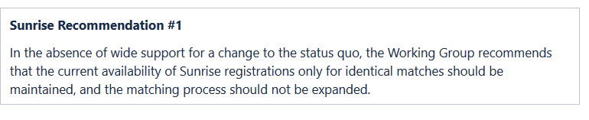
- Please choose one of the following responses for Sunrise Recommendation #1:

Mark only one oval.

Support Recommendation as written
Support Recommendation concept with minor change Significant change required
Do not support Recommendation No opinion

- If you wish to (a) propose changes to Sunrise Recommendation #1; and/or (b) provide a rationale for your response, please do so here.

Exact matches are already too broad. They discount the non-trademark and nominative fair use allowing trademark owners an unfettered right of first registration in gTLDs what are clearly unrelated to the categories of goods and services in which their trademarks are registered.

Sunrise Recommendation #2
Please find the link to this Recommendation and its context here: https://community.icann.org/x/ryGJBw
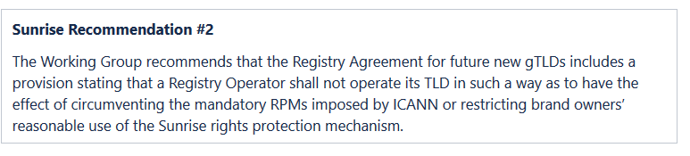

- Please choose one of the following responses for Sunrise Recommendation #2:

Mark only one oval.

Support Recommendation as written
Support Recommendation concept with minor change Significant change required
Do not support Recommendation No opinion

- If you wish to (a) propose changes to Sunrise Recommendation #2; and/or (b) provide a rationale for your response, please do so here.

We strongly oppose this recommendation as it overbroad and stands to be misinterpreted in many ways. The context says that this recommendation is intended to be limited to Premium Names (domain names selected and then sold by new gTLDs at high prices), and if that were the case, the recommendation would be acceptable. However, as written, the recommendation can damage any registries who do not go above and beyond the current consensus policies to further protect trademark owners. That is not acceptable.

Sunrise Recommendation #3
Please find the link to this Recommendation and its context here: https://community.icann.org/x/siGJBw

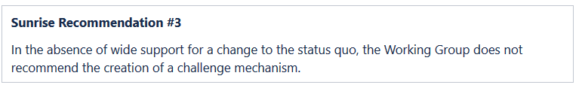

- Please choose one of the following responses for Sunrise Recommendation #3:

Mark only one oval.

Support Recommendation as written
Support Recommendation concept with minor change Significant change required
Do not support Recommendation No opinion

- If you wish to (a) propose changes to Sunrise Recommendation #3; and/or (b) provide a rationale for your response, please do so here.
This recommendation is very vague. The “context” discussion indicates that it applies to Reserved and Premium Names, and if that is the case, we support the recommendation. But as written, it could be misinterpreted to mean that no challenges processes should be created – which is a conclusion the WG has not studied or made.

Sunrise Recommendation #4
Please find the link to this Recommendation and its context here: https://community.icann.org/x/tCGJBw

- Please choose one of the following responses for Sunrise Recommendation #4:
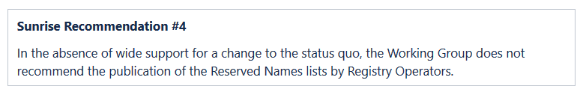

Mark only one oval.

Support Recommendation as written
Support Recommendation concept with minor change Significant change required
Do not support Recommendation No opinion

- If you wish to (a) propose changes to Sunrise Recommendation #4; and/or (b) provide a rationale for your response, please do so here.

Sunrise Recommendation #5
Please find the link to this Recommendation and its context here: https://community.icann.org/x/tiGJBw

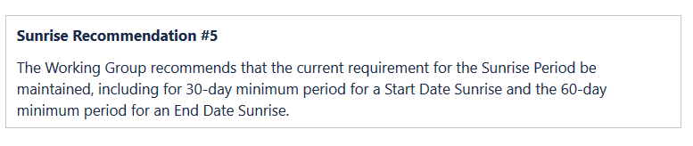
- Please choose one of the following responses for Sunrise Recommendation #5:

Mark only one oval.

Support Recommendation as written
Support Recommendation concept with minor change Significant change required
Do not support Recommendation No opinion

- If you wish to (a) propose changes to Sunrise Recommendation #5; and/or (b) provide a rationale for your response, please do so here.

If the Sunrise Period continues, then we recommend it continue with the existing terms, per this Sunrise Recommendation #5. But see #6 below.

Sunrise Recommendation #6
Please find the link to this Recommendation and its context here: https://community.icann.org/x/uCGJBw
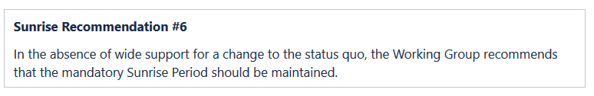
- Please choose one of the following responses for Sunrise Recommendation #6:

Mark only one oval.

Support Recommendation as written
Support Recommendation concept with minor change Significant change required
Do not support Recommendation No opinion

- If you wish to (a) propose changes to Sunrise Recommendation #6; and/or (b) provide a rationale for your response, please do so here.

Because of the secrecy of the Trademark Clearinghouse (something never stipulated or agreed by the initial drafters, the GNSO Council or the ICANN Board), and because the Sunrise Period rights for trademark owners extend far beyond the protected goods and services of their trademark rights (an overreach that the WG appears inclined to keep), we do not support the continuing use of the Sunrise Period.

We further note that it was a little-used mechanism, likely indicating that trademark owners do not find it valuable either.

Sunrise Recommendation #7
Please find the link to this Recommendation and its context here: https://community.icann.org/x/uiGJBw
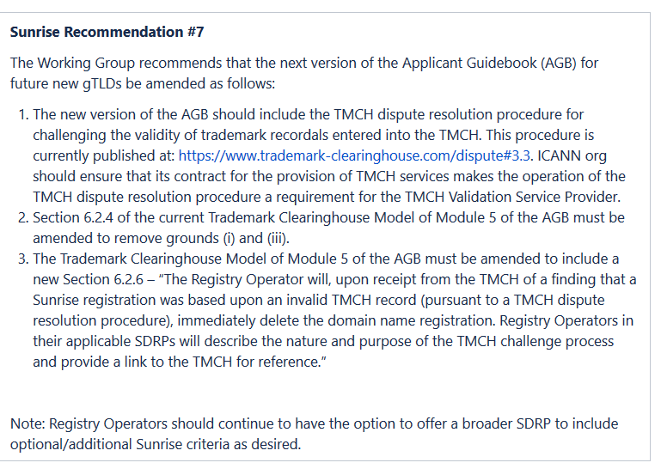

- Please choose one of the following responses for Sunrise Recommendation #7:

Mark only one oval.

Support Recommendation as written
Support Recommendation concept with minor change Significant change required
Do not support Recommendation No opinion

- If you wish to (a) propose changes to Sunrise Recommendation #7; and/or (b) provide a rationale for your response, please do so here.

Sunrise Recommendation #8
Please find the link to this Recommendation and its context here: https://community.icann.org/x/vCGJBw
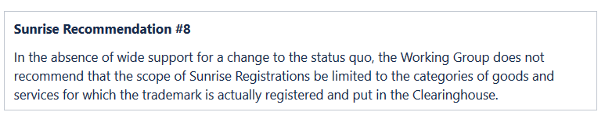

- Please choose one of the following responses for Sunrise Recommendation #8:

Mark only one oval.

Support Recommendation as written
Support Recommendation concept with minor change Significant change required
Do not support Recommendation No opinion

- If you wish to (a) propose changes to Sunrise Recommendation #8; and/or (b) provide a rationale for your response, please do so here.

We strongly oppose this recommendation. It is vitally important that the Sunrise Period be limited to allowing registrations of trademarks only in those gTLDs to which the trademark is logically related. Othewrise, the ICANN policy goes far beyond law to allow ownership of strings and words outside context or categories of goods and services – which is a right never provided in trademark law. [See response to question 50]

Sunrise Question #1
Please find the link to this Question and its context here: https://community.icann.org/x/viGJBw

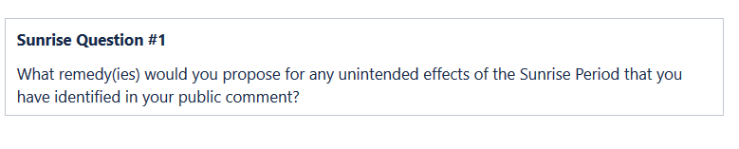
- Sunrise Q1. What remedy(ies) would you propose for any unintended effects of the Sunrise Period that you have identified in your public comment?

The Analysis Group report and investigative stories show that some trademark owners are registering common words for the purpose of gaining privileged access to new domain names in areas completely unrelated to their legal rights. [See response to question 50.] In doing so, they are depriving legitimate noncommercial organizations and entrepreneurs of their ability to register a domain name. These unintended effects should be more closely reviewed, and corrected, by the RPM WG in this Phase 1.

Sunrise Question #2
Please find the link to this Question and its context here: https://community.icann.org/x/wCGJBw

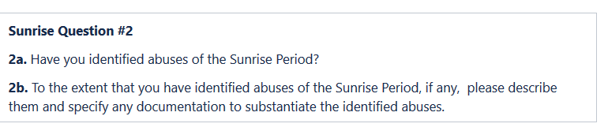
- Sunrise Q2a. Have you identified abuses of the Sunrise Period?

Mark only one oval.

Yes No
Not sure
Other:

- Sunrise Q2b. To the extent that you have identified abuses of the Sunrise Period, if any, please describe them and specify any documentation to substantiate the identified abuses.

The Analysis Group report and investigative stories researched and shared during WG meetings clearly show that trademark owners are registering common words into the Trademark Clearinghouse. [See response to question 50.] The secrecy of the Trademark Clearinghouse prevents any investigation or audit of abuse and misuse of Sunrise except on an anecdotal basis, but it is clear that TMCH misuse is occurring. See https://onlinedomain.com/2014/04/15/legal/fake-trademarks-stealing-generic-domains-in-new-gtld-sunrises/ (identifying 330 domain names for terms such as social, cloud, and direct (registered in Switzerland as trademarks for pens) registered across multiple unrelated gTLDs in Sunrise).

Sunrise Question #3
Please find the link to this Question and its context here: https://community.icann.org/x/wiGJBw

This question is directed to registry operators who adopted different types of pre-Sunrise period processes (e.g., to allow pre-registration of all provinces in Catalonia) and therefore NCSG does not need to reply.

Note:
- The Working Group recommends that public comment be sought on questions #3a-d from Registry Operators.

- The Working Group asks Registry Operators to be specific about which program(s) (i.e., ALP , QLP , and/or LRP ) they are referring in their responses to all questions and what the shortcomings of each of those mechanisms are.

- The Working Group also recommends that public comment be sought on question #3e from non-Registry Operators.

- Sunrise Q3a-1. Question to Registry Operators -- If you did not attempt an ALP, QLP, or LRP, was the reason for not taking advantage of those programs related to how they integrate with Sunrise?

- Sunrise Q3a-2. Question to Registry Operators -- Were you able to achieve your goals in a different way (such as by combining any or all of these programs)?

- Sunrise Q3b-1. Question to Registry Operators -- If you did attempt an ALP, QLP, or LRP (or combination) but didn’t successfully use any, was the reason you did not take advantage of those programs related to how they integrate with Sunrise?

- Sunrise Q3b-2. Question to Registry Operators -- Were you able to achieve your goals in a different way? For instance, some Registry Operators may have used the QLP 100 (Section 3.2 of Registry Agreement Specification 5 ) (plus IDN variants) in combination with registry-reserved names to obtain the names they needed. Did you do this?

- Sunrise Q3b-3. Question to Registry Operators -- If so, were you able to reserve or allocate all the names you needed to?

(or combination), did you experience any unanticipated trouble with integrating the Sunrise Period into your launch?

- Sunrise Q3c-2. Question to Registry Operators -- Specifically, were you able to allocate all of the names you needed to allocate under those programs before the Sunrise Period?

- Sunrise Q3d-1. Question to Registry Operators -- For each issue you have identified in your responses to questions #3a-c, please also include a suggested mitigation path. What do you suggest the RPM Working Group consider to help alleviate the pain points and make those programs more useful and functional, while still respecting the trademark protection goals of the Sunrise Period?

changes to these programs before another round of new gTLDs (that is, are these issues worth “holding up” another round for, or are the work-arounds tolerable)?

- Sunrise Q3e. Question to Non-Registry Operators -- Did you experience struggles with the way ALP, QLP, or LRPs (or a combination) integrated with Sunrise, either as registrar, as a brand owner, or as a domain name registrant?

Sunrise Question #4
Please find the link to this Question and its context here: https://community.icann.org/x/xCGJBw Note: The Working Group recommends that the following guidance be sought from Registry Operators.
Another question to registry operators:

- Sunrise Q4a-1. Question to Registry Operators -- If you had/have a business model that was in some way restrained by the 100-name pre Sunrise limit for names registries can reserve under Section 3.2 of Registry Agreement Specification 5, or the practical problems with the ALP, please share your experience and suggested path to improvement.

- Sunrise Q4a-2. Question to Registry Operators -- What was your work-around, if any? For instance, if you withheld names from registration (“reserved” names), how well did that work?

- Sunrise Q4b-1. Question to Registry Operators -- If the Working Group were to identify specialized gTLDs as a key concern that required changes to the way the Sunrise Period operates, are there other TLDs, besides GeoTLDs that did or will encounter the same problem?

- Sunrise Q4b-2. Question to Registry Operators -- What suggestions do you have for work-arounds or solutions that will not diminish the protections available from the Sunrise Period (balanced with the need to finish this work in a timely manner)?

- Sunrise Q4c-1. Question to Registry Operators -- Did you initially intend (prior to the implementation of Sunrise rules in the original Applicant Guidebook) to offer a special Sunrise before the regular Sunrise that targeted local trademark owners?
Mark only one oval.

Yes No
Not sure
Other:

- Sunrise Q4c-2. Question to Registry Operators -- For instance, would the ability to offer a special “pre-Sunrise” Sunrise solve any problems?
Mark only one oval.

Yes No
No opinion
Other:

- Sunrise Q4c-3. Question to Registry Operators -- If so, would you have validated the marks in some way?
Mark only one oval.

Yes No
No opinion
Other:

- Sunrise Q4c-4. Question to Registry Operators -- How would you have resolved conflicts between trademark holders that got their domains during the first Sunrise and trademark holders who had an identical trademark in the TMCH that was registered prior to Sunrise?

Sunrise Question #5
Please find the link to this Question and its context here: https://community.icann.org/x/xiGJBw

Note: The Working Group recommends that public comment be sought from trademark holders who use non- English scripts/languages.

Addressed to trademark owners with domain names in non-English scripts.
- Sunrise Q5a. Question to trademark holders who use non-English scripts/languages -- Did you encounter any problems when you attempted to participate in Sunrise using non-English scripts/languages?
Mark only one oval.

Yes No
Not sure
Other:

- Sunrise Q5b. Question to trademark holders who use non-English scripts/languages -- If so, please describe problems you have encountered.

- Sunrise Q5c. Question to trademark holders who use non-English scripts/languages -- Do you have suggestions on how to enable trademark holders who use non-English scripts/languages to effectively participate in Sunrise?

Save Your Progress

- Do you want to save your progress and quit for now? You will be able to return to the form to complete at a later time.
Mark only one oval.

Yes
No, I wish to continue to the next section

Section 6: Trademark Claims Service Preliminary Recommendations & Community Questions
  - This section seeks to obtain input on all the preliminary recommendations and questions related to the Trademark Claims service offered through the TMCH.

  - Related Trademark Claims preliminary recommendations and questions are placed next to each other for easy reference.

Trademark Claims Recommendation #1
Please find the link to this Recommendation and its context here: https://community.icann.org/x/2yGJBw Note: Trademark Claims Recommendation #1 has an associated Trademark Claims Question #1 below.
Trademark Claims Recommendation #1
The Working Group recommends that the language of the Trademark Claims Notice be revised, in accordance with the Implementation Guidance outlined below. This recommendation aims to help enhance the intended effect of the Trademark Claims Notice by improving the understanding of recipients, while decreasing any unintended effects of deterring good-faith domain name applications.

- Please choose one of the following responses for Trademark Claims Recommendation #1:
Mark only one oval.

Support Recommendation as written
Support Recommendation concept with minor change Significant change required
Do not support Recommendation No opinion

- If you wish to (a) propose changes to Trademark Claims Recommendation #1; and/or (b) provide a rationale for your response, please do so here.

Trademark Claims Question #1
Please find the link to this Question and its context here: https://community.icann.org/x/2yGJBw Note: Trademark Claims Question #1 is related to Trademark Claims Recommendation #1.

- Trademark Claims Q1a-1. Have you identified any inadequacies or shortcomings of the Claims Notice?
Mark only one oval.

Yes No
Not sure
Other:

- Trademark Claims Q1a-2. If so, what are they?

The TM Claims notice is very difficult for potential registrants to understand, and very intimidating. These issues have been discussed at length in the WG and we look forward to a newly draft notice soon.

- Trademark Claims Q1b. Do you have suggestions on how to improve the Claims Notice in order to address the inadequacies or shortcomings?

Written in much clearer and more straightforward language with a fair and balanced explanation; and translated into many languages.

Trademark Claims Recommendation #2
Please find the link to this Recommendation and its context here: https://community.icann.org/x/3SGJBw
Trademark Claims Recommendation #2
The Working Group recommends that delivery of the Trademark Claims Notice be both in English as well as the language of the registration agreement. In this regard, the Working Group recommends:
- Changing the relevant language in the current Trademark Clearinghouse Rights Protection Mechanism Requirements[1] on this topic (Section 3.3.1.2) to “...registrars MUST provide the Claims Notice in English and in the language of the registration agreement.”
- The Claims Notice should include a link to a webpage on the ICANN org website containing translations of the Claims Notice in all six UN languages.

- Please choose one of the following responses for Trademark Claims Recommendation #2:
Mark only one oval.

Support Recommendation as written
Support Recommendation concept with minor change Significant change required
Do not support Recommendation No opinion

- If you wish to (a) propose changes to Trademark Claims Recommendation #2; and/or (b) provide a rationale for your response, please do so here.

translations are key for registrants to be able to understand the notice.

Trademark Claims Recommendation #3
Please find the link to this Recommendation and its context here: https://community.icann.org/x/3yGJBw

Trademark Claims Recommendation #3
The Working Group recommends that the current requirement for only sending the Claims Notice before a registration is completed be maintained.

- Please choose one of the following responses for Trademark Claims Recommendation #3:
Mark only one oval.

Support Recommendation as written
Support Recommendation concept with minor change Significant change required
Do not support Recommendation No opinion

- If you wish to (a) propose changes to Trademark Claims Recommendation #3; and/or (b) provide a rationale for your response, please do so here.

Trademark Claims Recommendation #4
Please find the link to this Recommendation and its context here: https://community.icann.org/x/4SGJBw Note: Trademark Claims Recommendation #4 has an associated Trademark Claims Question #2 below.
Trademark Claims Recommendation #4
The Working Group recommends, in general, that the current requirement for a mandatory Claims Period be maintained, including the minimum initial 90-day period when a TLD opens for general registration.
- Please choose one of the following responses for Trademark Claims Recommendation #4:
Mark only one oval.

Support Recommendation as written
Support Recommendation concept with minor change Significant change required
Do not support Recommendation No opinion

- If you wish to (a) propose changes to Trademark Claims Recommendation #4; and/or (b) provide a rationale for your response, please do so here.

Trademark Claims Recommendation #5
Please find the link to this Recommendation and its context here: https://community.icann.org/x/4yGJBw Note: Trademark Claims Recommendation #5 has an associated Trademark Claims Question #2 below.
Trademark Claims Recommendation #5
The Working Group recommends that the current requirement for a mandatory Claims Period should continue to be uniform for all types of gTLDs in subsequent rounds, including for the minimum initial 90-day period when a TLD opens for general registration.

- Please choose one of the following responses for Trademark Claims Recommendation #5:
Mark only one oval.

Support Recommendation as written
Support Recommendation concept with minor change Significant change required
Do not support Recommendation No opinion

- If you wish to (a) propose changes to Trademark Claims Recommendation #5; and/or (b) provide a rationale for your response, please do so here.

Trademark Claims Question #2
Please find the link to this Question and its context here: https://community.icann.org/x/5yGJBw Note: Trademark Claims Question #2 is related to Trademark Claims Recommendations #4 & #5.
Trademark Claims Question #2
2a. Is there a use case for exempting a gTLD that is approved in subsequent expansion rounds from the requirement of a mandatory Claims Period due to the particular nature of that gTLD? Such type of gTLD might include: (i) “highly regulated” TLDs that have stringent requirements for registering entities, on the order of .bank; and/or (ii) “Dot Brand” TLDs whose proposed registration model demonstrates that the use of a Trademark Claims Service is unnecessary.
2b. If the Working Group recommends exemption language, what are the appropriate guardrails ICANN should use when granting the exception (e.g. Single-registrant? Highly-regulated or manually hand-registered domains[1]? Something else?)?

Note: This question is related to Trademark Claims Recommendations #4 and #5.

- Trademark Claims Q2a. Is there a use case for exempting a gTLD that is approved in subsequent expansion rounds from the requirement of a mandatory Claims Period due to the particular nature of that gTLD? Such type of gTLD might include: (i) “highly regulated” TLDs that have stringent requirements for registering entities, on the order of .bank; and/or (ii) “Dot Brand” TLDs whose proposed registration model demonstrates that the use of a Trademark Claims Service is unnecessary.

Future gTLDs dedicated to noncommercial speech would be a good example of a gTLD that need not have a TM Claims Period. Also one dedicated to Names.

- Trademark Claims Q2b. If the Working Group recommends exemption language, what are the appropriate guardrails ICANN should use when granting the exception (e.g. Single-registrant? Highly-regulated or manually hand-registered domains? Something else?)?

Trademark Claims Recommendation #6
Please find the link to this Recommendation and its context here: https://community.icann.org/x/5SGJBw

Trademark Claims Recommendation #6
In the absence of wide support for a change to the status quo, the Working Group recommends that the current exact matching criteria for the Claims Notice be maintained.

- Please choose one of the following responses for Trademark Claims Recommendation #6:
Mark only one oval.

Support Recommendation as written
Support Recommendation concept with minor change Significant change required
Do not support Recommendation No opinion

- If you wish to (a) propose changes to Trademark Claims Recommendation #6; and/or (b) provide a rationale for your response, please do so here.

Save Your Progress

- Do you want to save your progress and quit for now? You will be able to return to the form to complete at a later time.
Mark only one oval.

Yes
No, I wish to continue to the next section

Section 7: TM- PDDRP Preliminary Recommendation
This section seeks to obtain input on the preliminary recommendation related to the Trademark Post-Delegation Dispute Resolution Procedure (TM-PDDRP).

TM-PDDRP Recommendation #1
Please find the link to this Recommendation and its context here: https://community.icann.org/x/9SOJBw

TM-PDDRP Recommendation #1
The Working Group recommends that Rule 3(g) of the Trademark Post-Delegation Dispute Resolution Procedure (TM-PDDRP) Rules be modified, to provide expressly that multiple disputes filed by unrelated entities against a Registry Operator[1] may be initially submitted as a joint Complaint, or may, at the discretion of the Panel, be consolidated upon request.

- Please choose one of the following responses for TM-PDDPR Recommendation
#1:

Mark only one oval.

Support Recommendation as written OR
Support Recommendation concept with minor change Significant change required
Do not support Recommendation No opinion

- If you wish to (a) propose changes to TM-PDDRP Recommendation #1; and/or (b) provide a rationale for your response, please do so here.

Save Your Progress

- Do you want to save your progress and quit for now? You will be able to return to the form to complete at a later time.
Mark only one oval.

Yes
No, I wish to continue to the next section

Section 8: URS Individual Proposals (Non- Recommendations)
- This section seeks to obtain input on all the individual proposals related to the Uniform Rapid Suspension System (URS). These proposals were submitted by individual working group members but did not rise to the level of becoming preliminary recommendations.

- Please note that some Individual Proposals contain associated questions that the Working Group specifically invites public comment.

URS Individual Proposal #1
Please find link to this Individual Proposal and its context here: https://community.icann.org/x/6iGJBw

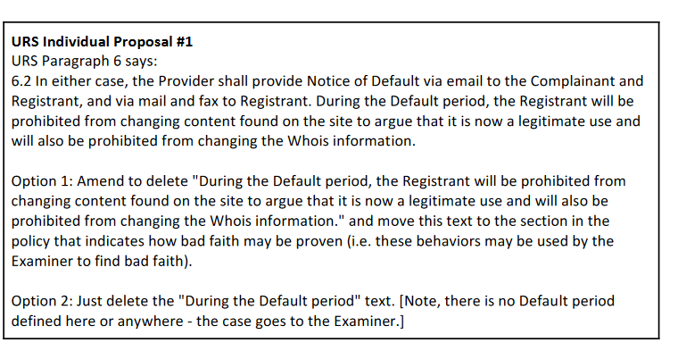

- Please choose one of the following responses for URS Individual Proposal #1:

Mark only one oval.

Support Proposal as written [or]
Support Proposal concept with minor change Significant change required
Do not support Proposal No opinion

- If you wish to (a) propose changes to URS Individual Proposal #1; and/or (b) provide a rationale for your response, please do so here.

There was no evidence of a problem of post-complaint changes in the WG’s detailed analysis of the URS cases. To the extent that the current rule purports to prohibit any changes (or tries to deter registrants from making changes), it has apparently proven impossible to implement; there is no evidence that registrants are even receiving this message. Plus, there may be completely legal and other reasons why an organization or business may need to update their website, including contact information on the website, during the pendency of URS proceeding. First, this contact information (such as a phone number or location) may change and need to be updated. Further, maintaining accurate contact information, we understand, is a legal requirement in some countries, including Germany, for businesses engaged in sales to end users. Separately, many websites include, e.g., Twitter feeds or other automatically provided content. Removing the automatically provided content would be a change—but allowing the automatically provided content to change would also be a change.

In addition, since most URS cases involve defaults, it is not clear that the registrants subjected to this requirement even know of it. There has been no evidence developed that any registrant has (1) cured a default, then (2) argued that subsequent changes prove its good faith.

Thus, option 2—deleting the statement—is preferable. Option 1 is not as good because post-complaint changes should not be deemed to be evidence of bad faith, even if they cannot show good faith. Some registrants may attempt to address a trademark claimant’s objection by making changes to the website. In many circumstances that could be good faith, though it might not always be. Option 1 would also retain the problem that, as the proponent points out, there isn’t an explicit definition of “default period” in the rest of the policy.

URS Individual Proposal #2
Please find link to this Individual Proposal and its context here: https://community.icann.org/x/fSCJBw

Note: The Working Group particularly seeks public comment from the Contracted Parties House with regard to this proposal

URS Individual Proposal #2 Legal requirements should be moved from the technical document "URS High Level Technical Requirements for Registries and Registrars"55to another document (URS Procedure56or URS Rules57).
- Please choose one of the following responses for URS Individual Proposal #2:

Mark only one oval.

Support Proposal as written OR
Support Proposal concept with minor change Significant change required
Do not support Proposal No opinion

- If you wish to (a) propose changes to URS Individual Proposal #2; and/or (b) provide a rationale for your response, please do so here.

URS Individual Proposal #3
Please find link to this Individual Proposal and its context here: https://community.icann.org/x/7CGJBw

Revise URS Policy Paragraph 10 to reflect the following new provisions:10.3 There shall be an option for a successful or unsuccessful Complainant to extend the registration period for one additional year at commercial rates.10.5 Notwithstanding any locking of a domain name pursuant to Paragraph 4.1 and notwithstanding the suspension of domain name pursuant to Paragraph 10.2, a registrant shall be entitled to renew a subject domain name registration and theRegistry shall permit same in accordance with its usual commercial rates for a period of up to one year.

- Please choose one of the following responses for URS Individual Proposal #3:

Mark only one oval.

Support Proposal as written
Support Proposal concept with minor change Significant change required
Do not support Proposal No opinion

- If you wish to (a) propose changes to URS Individual Proposal #3; and/or (b) provide a rationale for your response, please do so here.

There is no evidence of a problem that this proposal is addressing. Further, if the Complainant loses, it has no right to extend the registration for any additional time at any additional rates.

URS Individual Proposal #6
Please find link to this Individual Proposal and its context here: https://community.icann.org/x/7iGJBw

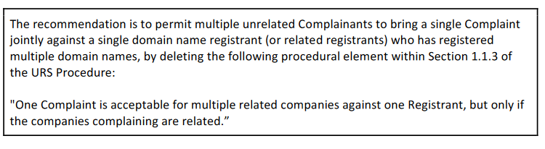
- Please choose one of the following responses for URS Individual Proposal #6:

Mark only one oval.

Support Proposal as written
Support Proposal concept with minor change Significant change required
Do not support Proposal No opinion

- If you wish to (a) propose changes to URS Individual Proposal #6; and/or (b) provide a rationale for your response, please do so here.

We strongly oppose this proposal which is completely inconsistent with the goals of the URS – a rapid and cheap method for taking down clearly-abusive complaints. There will be nothing rapid or cheap about allowing multiple companies to file together – and the system will be becoming overwhelming to Respondants and Providers alike. Further, there is no evience of a problem that needs remedy here.

URS Individual Proposal #11
Please find link to this Individual Proposal and its context here: https://community.icann.org/x/8CGJBw Note: URS Individual Proposal #11 has specific questions below seeking public comment.
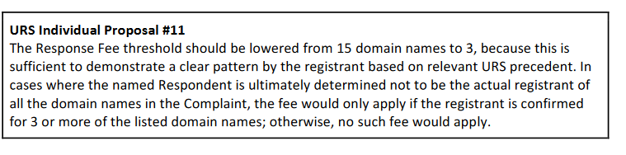
- Please choose one of the following responses for URS Individual Proposal #11:

Mark only one oval.

Support Proposal as written
Support Proposal concept with minor change Significant change required
Do not support Proposal No opinion

- If you wish to (a) propose changes to URS Individual Proposal #11; and/or (b) provide a rationale for your response, please do so here.

We strongly oppose this proposal. There is no evidentiary basis for the reduction of the threshold of 15. Further, the threshold of 15 as the minimum number for a response fee was part of the balance crafted by the original drafters of the URS. Three is far too low a threshold to demonstrate any clear pattern of abuse. It will also further discourage responses from those unable to pay these fees.

Further, evidence gathered in the WG’s extensive URS data collection did not point to a problem with the current threshold. The proponent identifies 43 cases involving 3 or more domain names. Based on the data collected by Rebecca Tushnet: Of cases listing 3 or more domain names, there were 8 responses filed; the rest were defaults. The responses were filed in 5 cases involving 3 domain names and 1 case involving each of 6, 5, and 4 domain names. The claim was denied in the case against the 5 domain names while the domain names were suspended in the other cases in that subset. Because of the high level of defaults—and the relatively high level of claim denial in the subset of cases involving multiple domains with responses—there is no need to deter responses by imposing response fees.

Of cases listing 2 or more domain names, there were 27 responses filed, and the claim was denied in 5 of those cases. In the subset of “2 or more domain names,” claims were only denied if a response was filed, indicating that the ability to respond allows the respondent to make important arguments and defeat improper claim. Lowering the threshold would not do anything against serious abuses (where dozens or hundreds of domain names are already registered, and which are already almost certain to default) and would raise the costs of response for registrants who may have arguments worth considering. The response fee is an amount far greater than the registration cost for a few domains, and it might represent a significant expense for a registrant in many countries.

- URS Individual Proposal #11 - Q1. Should the current Response Fee threshold of fifteen (15) domain names be lowered?
Mark only one oval.

Yes No
No opinion
Other:

- URS Individual Proposal #11 - Q2. If so, what should be the new threshold?

15 remains the appropriate and agreed upon threshold.

URS Individual Proposal #13
Please find link to this Individual Proposal and its context here: https://community.icann.org/x/fyCJBw Note: URS Individual Proposal #13 has a specific question below seeking public comment.
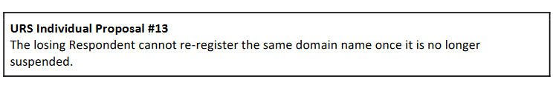

- Please choose one of the following responses for URS Individual Proposal #13:

Mark only one oval.

Support Proposal as written
Support Proposal concept with minor change Significant change required
Do not support Proposal No opinion

- If you wish to (a) propose changes to URS Individual Proposal #13; and/or (b) provide a rationale for your response, please do so here.

We strongly oppose this proposal as part of a search for ever-expanding remedies in the URS. The current remedies are more than sufficient and the URS is working as designed.

- URS Individual Proposal #13 - Q1. How feasible would it be to enforce this Proposal should it be implemented?

Further, this remedy would be virtually impossible to implement this proposal and the costs would be staggering. There is no plausible system proposed to identify attempted re-registrants, and it would create serious privacy problems for everyone who had to be screened as a result.

URS Individual Proposal #15
Please find link to this Individual Proposal and its context here: https://community.icann.org/x/8iGJBw Note: URS Individual Proposal #15 has specific questions below seeking public comment.
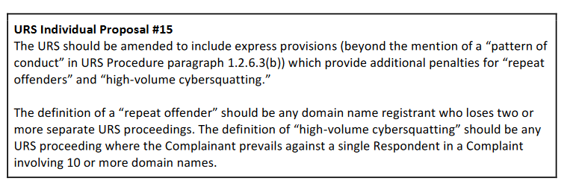

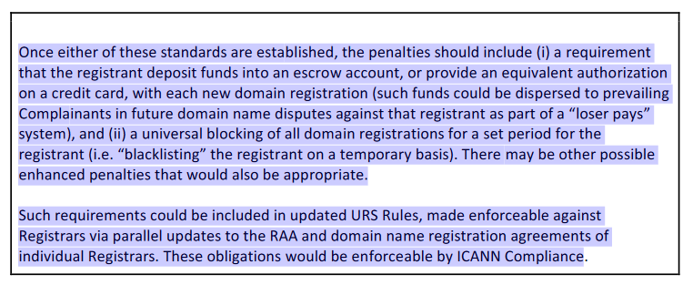
- Please choose one of the following responses for URS Individual Proposal #15:

Mark only one oval.

Support Proposal as written
Support Proposal concept with minor change Significant change required
Do not support Proposal No opinion

- If you wish to (a) propose changes to URS Individual Proposal #15; and/or (b) provide a rationale for your response, please do so here.

Two negative decisions is far too low for the label of “repeat offender.” Further, no evidence found by the WG indicates any need for such a dramatic reduction or such a severe change in the balance of the URS.

Further, there is no evidence for a new definition of “repeat offender” or “high-volume cybersquatting.” Had the WG felt these issues to be a problem, it would have more actively pursued this discussion.

The idea of requiring escrow accounts for respondents and blacklisting them goes far beyond the limited and rapid nature of the URS. It also would shift the URS into one with remedies far more powerful and far-reaching than the UDRP (which was never the original intent). These ideas absolutely circumvent the limited nature of the URS and will make the system ridiculously complicated and expensive.

- URS Individual Proposal #15 - Q1. Is the proposed definition of "repeat offender" in this Proposal appropriate?
Mark only one oval.

Yes No
No opinion
Other:

- URS Individual Proposal #15 - Q2. Is the proposed definition of "high-volume cybersquatting" in this Proposal appropriate?
Mark only one oval.

Yes No
No opinion
Other:

- URS Individual Proposal #15 - Q3. How feasible would it be to implement this Proposal?

The idea of requiring escrow accounts for respondents and blacklisting them goes far beyond the limited and rapid nature of the URS. It also would shift the URS into one with remedies far more powerful and far-reaching than the UDRP (which was never the original intent). These ideas absolutely circumvent the limited nature of the URS and will make the system ridiculously complicated and expensive.

URS Individual Proposal #16
Please find link to this Individual Proposal and its context here: https://community.icann.org/x/9CGJBw Note: URS Individual Proposal #16 has a specific question below seeking public comment.

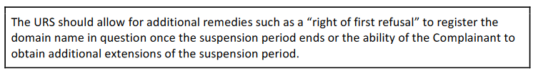

- If you wish to (a) propose changes to URS Individual Proposal #16; and/or (b) provide a rationale for your response, please do so here.

We strongly oppose this proposal as it effectively creates a transfer of the domain name to the trademark owner – a mechanism expressly rejected by the drafters of the URS system. It is out of the question.

- URS Individual Proposal #16 - Q1. How feasible would it be to implement this Proposal?

It is completely unfeasible in addition to completely undermining the URS and the UDRP.

URS Individual Proposal #22
Please find link to this Individual Proposal and its context here: https://community.icann.org/x/gSCJBw Note: URS Individual Proposal #22 has specific questions below seeking public comment.

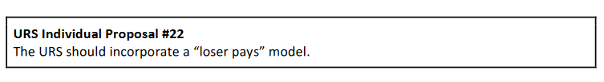

- If you wish to (a) propose changes to URS Individual Proposal #22; and/or (b) provide a rationale for your response, please do so here.

Strongly oppose this proposal as completely inconsistent with the URS and UDRP – proceedings far cheaper and faster than court and dependent on the complainant playing low and reasonable fees for the evaluation he/she/it seeks.

- URS Individual Proposal #22 - Q1. Is a "loser pays" model appropriate for the URS?

Mark only one oval.

Yes No
No opinion
Other:

- URS Individual Proposal #22 - Q2. Please provide input on the definition of specific criteria mentioned in this Proposal (e.g., “repeat offender” over a defined time period, and “high-volume cybersquatting”).

The input is inappropriate as the proposal reaches far beyond anything evaluated by the full WG for recommendations, and far outside anything justified or shown by the evidence presented in the URS data gathered.

- URS Individual Proposal #22 - Q3. Please provide input on the specific item(s) that should be paid in a “loser pays” model (e.g., administrative fees, attorneys’ fees).

This question is also inappropriate as a loser-pays model is anathema to the goals and balances of the URS as created by ICANN and adopted for new gTLDs.

- URS Individual Proposal #22 - Q4. Please provide input on the enforcement mechanism of the proposed "loser pays" model.

No enforcement mechanism is appropriate for discussion as this mechanism is completely inappropriate and out of sync with all other aspects of the URS

URS Individual Proposal #26
Please find link to this Individual Proposal and its context here: https://community.icann.org/x/9iGJBw

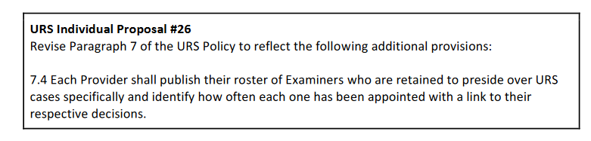
- Please choose one of the following responses for URS Individual Proposal #26:

Mark only one oval.

Support Proposal as written
Support Proposal concept with minor change Significant change required
Do not support Proposal No opinion

- If you wish to (a) propose changes to URS Individual Proposal #26; and/or (b) provide a rationale for your response, please do so here.

This proposal is completely consistent with URS rules requiring rotation of Panelists – and provides a clear, transparent and straight-forward way for ICANN and the Community to monitor compliance.

URS Individual Proposal #27
Please find link to this Individual Proposal and its context here: https://community.icann.org/x/_CGJBw
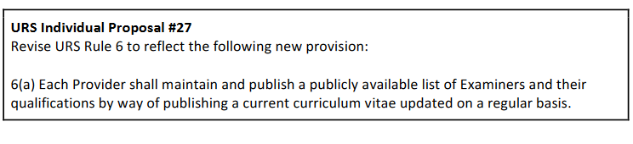

- Please choose one of the following responses for URS Individual Proposal #27:

Mark only one oval.

Support Proposal as written
Support Proposal concept with minor change Significant change required
Do not support Proposal No opinion

- If you wish to (a) propose changes to URS Individual Proposal #27; and/or (b) provide a rationale for your response, please do so here.

URS Individual Proposal #28
Please find link to this Individual Proposal and its context here: https://community.icann.org/x/_iGJBw Note: URS Individual Proposal #28 has specific questions below seeking public comment.
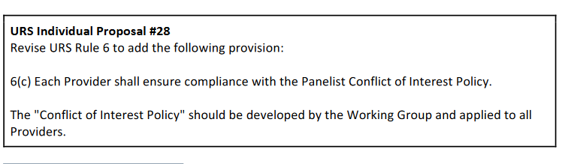
- Please choose one of the following responses for URS Individual Proposal #28:

Mark only one oval.

Support Proposal as written
Support Proposal concept with minor change Significant change required
Do not support Proposal No opinion

- If you wish to (a) propose changes to URS Individual Proposal #28; and/or (b) provide a rationale for your response, please do so here.

- URS Individual Proposal #28 - Q1. Please provide input on the suggested elements of the proposed “Panelist Conflict of Interest Policy”, should it be developed by the Working Group and applied to all URS Providers.

[Does anyone want to comment here? Comments welcome!]

- URS Individual Proposal #28 - Q2. Please list existing conflict of interest policies that can serve as examples for the proposed "Panelist Conflict of Interest Policy".

Does anyone want to comment here? Comments welcome!]

URS Individual Proposal #29
Please find link to this Individual Proposal and its context here: https://community.icann.org/x/-CGJBw Note: URS Individual Proposal #29 has a specific question below seeking public comment.
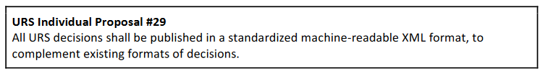
- Please choose one of the following responses for URS Individual Proposal #29:

Mark only one oval.

Support Proposal as written OR
Support Proposal concept with minor change Significant change required
Do not support Proposal No opinion

- If you wish to (a) propose changes to URS Individual Proposal #29; and/or (b) provide a rationale for your response, please do so here.

- URS Individual Proposal #29 - Q1. What are the cost and benefits of implementing the Proposal?

This proposal would make it easier for scholars and researchers to study URS decisions.

URS Individual Proposal #31
Please find link to this Individual Proposal and its context here: https://community.icann.org/x/-iGJBw

Note: URS Individual Proposal #31 stems from one of the general overarching Charter questions -- “General Overarching Charter Question #2: 2a. Should any of the New gTLD Program RPMs (such as the URS), like the UDRP, be Consensus Policies applicable to all gTLDs? 2b. If so, what are the transitional issues that would have to be dealt with as a consequence?”

Commenters have an opportunity to provide input on this general overarching Charter question in Section 10 of this form.

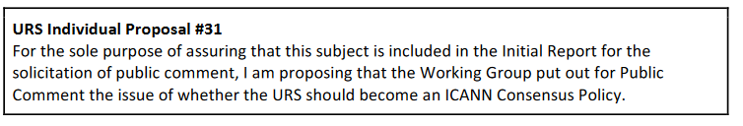
- If you wish to provide (a) a response to URS Individual Proposal #31; and/or (b) a rationale for your response, please do so here.

We strongly oppose the extension of URS to legacy gTLDs, particularly the older ones including .com, .org and .net. URS was part of a collection of special rights protections mechanisms created for the roll-out of New gTLDs.

This proposal provides no rationale to justify the extension of URS to older gTLDs, and in fact, such an extension would be utterly unfair to registrants in these older gTLDs. Many registrants have held their domain names for many years and never heard of the URS proceeding; they would be confused as to how to respond to a proceeding that is does not fit with their long-standing registrations.

The URS should remain a remedy for new gTLDs and not legacy gTLDs.

Please find link to this Individual Proposal and its context here: https://community.icann.org/x/ACKJBw Note: URS Individual Proposal #33 has a specific question below seeking public comment.
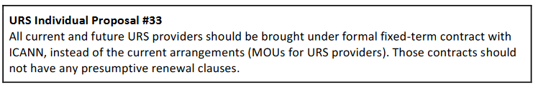
- Please choose one of the following responses for URS Individual Proposal #33:

Mark only one oval.

Support Proposal as written
Support Proposal concept with minor change Significant change required
Do not support Proposal No opinion

- If you wish to (a) propose changes to URS Individual Proposal #33; and/or (b) provide a rationale for your response, please do so here.

We support this proposal as written because it will allow for clearer oversight and better correction mechanisms.

- URS Individual Proposal #33 - Q1. What additional elements, if any, that need to be included to enhance ICANN’s Memorandums of Understanding (MOUs) with URS Providers and enforce their compliance?

URS Individual Proposal #34
Please find link to this Individual Proposal and its context here: https://community.icann.org/x/AiKJBw

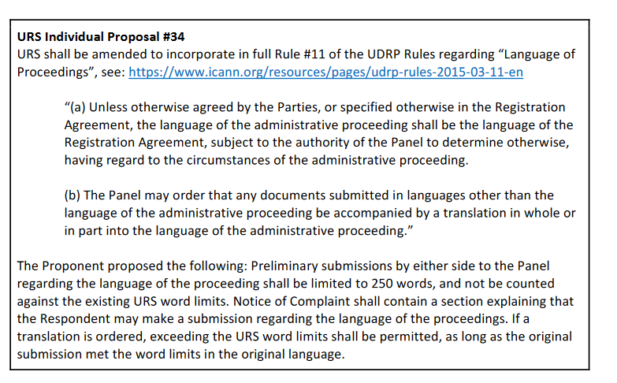
- Please choose one of the following responses for URS Individual Proposal #34:

Mark only one oval.

Support Proposal as written
Support Proposal concept with minor change Significant change required
Do not support Proposal No opinion

- If you wish to (a) propose changes to URS Individual Proposal #34; and/or (b) provide a rationale for your response, please do so here.

This recommendation provides important guidance regarding the language of the proceeding.

URS Individual Proposal #36
Please find link to this Individual Proposal and its context here: https://community.icann.org/x/BCKJBw

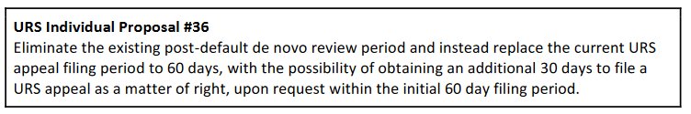
- Please choose one of the following responses for URS Individual Proposal #36:

Mark only one oval.

Support Proposal as written
Support Proposal concept with minor change Significant change required
Do not support Proposal No opinion

- If you wish to (a) propose changes to URS Individual Proposal #36; and/or (b) provide a rationale for your response, please do so here.

We oppose this individual proposal as there is no evidence of a problem in the existing data. We do not find any evidence of Respondents getting “three bites at the apple.” Further, this type of deep procedural change in the URS rules never received close attention or review from the full WG (which did not find it necessary to recommend such a fundamental change).

Save Your Progress

- Do you want to save your progress and quit for now? You will be able to return to the form to complete at a later time.
Mark only one oval.

Yes
No, I wish to continue to the next section

Section 9: TMCH Individual Proposals (Non- Recommendations)
- This section seeks to obtain input on all the individual proposals related to the Trademark Clearinghouse (TMCH). These proposals were submitted by individual working group members but did not rise to the level of becoming preliminary recommendations.

- Please note that some Individual Proposals contain associated questions that the Working Group specifically invites public comment.

TMCH Individual Proposal #1
Please find the link to this Individual Proposal and its context here: https://community.icann.org/x/eCCJBw Note: TMCH Individual Proposal #1 has specific questions below seeking public comment.
TMCH Individual Proposal #1
The TMCH should be responsible for educating rights-holders, domain name registrants and potential registrants about the services it provides.

- Please choose one of the following responses for TMCH Individual Proposal #1:

Mark only one oval.

Support Proposal as written
Support Proposal concept with minor change Significant change required
Do not support Proposal No opinion

- If you wish to (a) propose changes to TMCH Individual Proposal #1; and/or (b) provide a rationale for your response, please do so here.

At a minimum, the Trademark Clearinghouse website should have resources for both Complainants and Respondents. The TMCH website is the first place both sets of parties will go to find information and it is fair and balanced that the TMCH should provide information about the full process of sunrise and trademark claims notices for all who may have questions about them.

- TMCH Individual Proposal #1 - Q1. Should education about the TMCH and its services be provided?
Mark only one oval.

Yes No
No Opinion
Other:

- TMCH Individual Proposal #1 - Q2. If there should be education about the TMCH and its services, how and by whom should such education be provided?

At a minimum, the Trademark Clearinghouse website should have resources for both Complainants and Respondents. The TMCH website is the first place both sets of parties will go to find information and it is fair and balanced that the TMCH should provide information about the full process of sunrise and trademark claims notices for all who may have questions about them.

TMCH Individual Proposal #2 (1 of 2 proposals concerning design marks)
Please find the link to this Individual Proposal and its context here: https://community.icann.org/x/eyCJBw Note: TMCH Individual Proposals #2 & #3 have a specific question seeking public comment below.
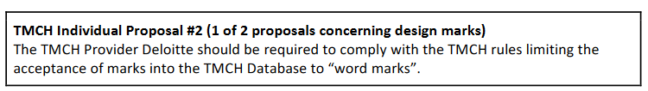
- Please choose one of the following responses for TMCH Individual Proposal #2:

Mark only one oval.

Support Proposal as written
Support Proposal concept with minor change Significant change required
Do not support Proposal No opinion

- If you wish to (a) propose changes to TMCH Individual Proposal #2; and/or (b) provide a rationale for your response, please do so here.

The protection of design and figurative marks was expressly not allowed by the multistakeholder group that wrote the rules that would adopted by the GNSO Council and the ICANN Board. Their rules were quite clear, and should be followed.

(To the extent there are few jurisdictions that do not differentiate between design/figurative marks and work marks, special provisions can be made; but not for the many jurisdications that do make such a distinction.) This proposal is merely a “reset” back to the original rules as adopted.

TMCH Individual Proposal #3 (2 of 2 proposals concerning design marks)
Please find the link to this Individual Proposal and its context here: https://community.icann.org/x/eyCJBw Note: TMCH Individual Proposals #2 & #3 have a specific question seeking public comment below.
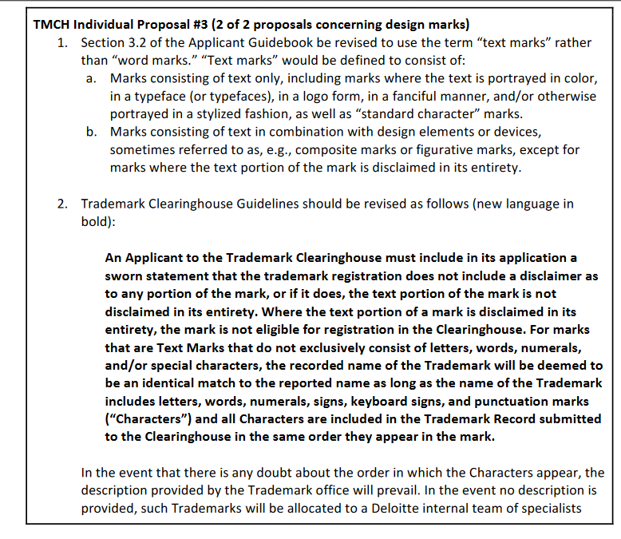
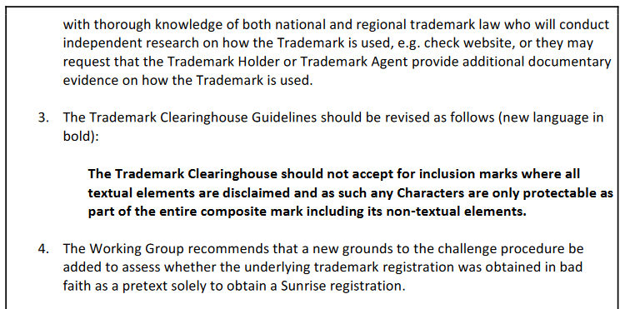
- Please choose one of the following responses for TMCH Individual Proposal #3:

Mark only one oval.

Support Proposal as written
Support Proposal concept with minor change Significant change required
Do not support Proposal No opinion

- If you wish to (a) propose changes to TMCH Individual Proposal #3; and/or (b) provide a rationale for your response, please do so here.

This proposal goes far beyond trademark law in its protection of design elements as basic word marks. Many design marks contain basic dictionary words and they are allowed to be registered only in the context of the design with its ornamentation and/or colors. This proposal expressly allows them to be protected far beyond the context of the design, in the TMCH and then via Sunrise and Trademark Claims Notices, far beyond their rights and protections under trademark law – and to the detriment of other businesses, organizations and individuals using the same common words and names.
John Berryhill has explored one abuse of the system, to control the dictionary term “physics.” http://domainincite.com/16492-how-one-guy-games-new-gtld-sunrise-periods#comment-75469

- TMCH Individual Proposals #2 & #3 - Q1. Do you have suggestions for ways to reconcile TMCH Individual Proposals #2 and #3?

No, the first proposal is consistent with the rules of the URS as written, and also consistent with existing trademark law, and the limits of trademark rights in design marks. The second proposal goes far beyond existing rights in trademark law – violating a basic principles of the New gTLD rights protection mechanism process. We do not see how these two proposals can be reconciled; they flatly contradict each other.

TMCH Individual Proposal #4 (1 of 2 proposals concerning geographical indications)
Please find the link to this Individual Proposal and its context here: https://community.icann.org/x/CSKJBw Note: TMCH Individual Proposals #4 & #5 have a specific question seeking public comment below.
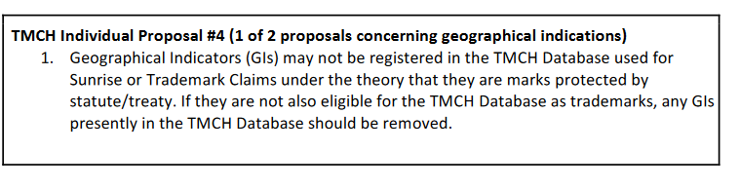
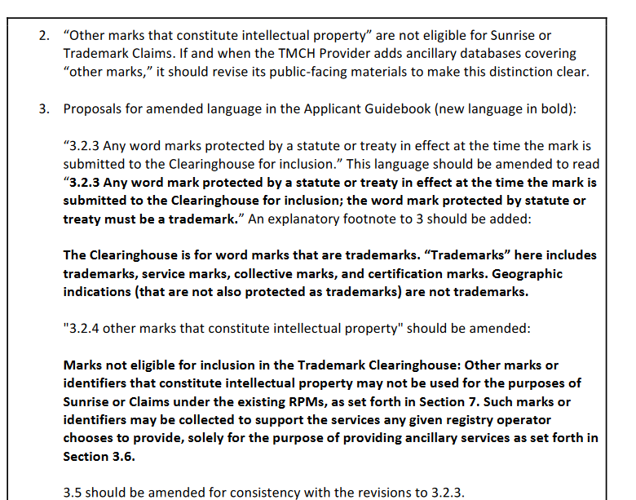
- Please choose one of the following responses for TMCH Individual Proposal #4:

Mark only one oval.

Support Proposal as written
Support Proposal concept with minor change Significant change required
Do not support Proposal No opinion

- If you wish to (a) propose changes to TMCH Individual Proposal #4; and/or (b) provide a rationale for your response, please do so here.

We agree strongly with the rationale presented with Proposal #4. “The TMCH Database is for trademarks: those that are registered as trademarks, confirmed by court decision as trademarks, or protected by statute or treaty that specifies the trademarks covered. Sunrise and TM Claims are for the protection of trademarks only. Geographical Indications/Appellations of Origin (“GIs”) are not eligible for protection in the mandatory Sunrise or Claims periods, save where they also qualify as trademarks.”

Geographical indications in one country are deemed generic marks in another country, e.g., champagne and swiss cheese. Even those who protect GIs do not claim that they are trademarks.

Accordingly Proposal 4 reflects an important finding of the WG – that GIs are doing into the TMCH and that future GIs should not be allowed. Should registries choose to protect GIs, they can do so using additional ancillary databases.

TMCH Individual Proposal #5 (2 of 2 proposals concerning geographical indications)
Please find the link to this Individual Proposal and its context here: https://community.icann.org/x/CSKJBw Note: TMCH Individual Proposals #4 & #5 have a specific question seeking public comment below.

- If you wish to (a) propose changes to TMCH Individual Proposal #5; and/or (b) provide a rationale for your response, please do so here.

Proposal 5 is largely overlapping with proposal 4. While there is not much objectionable in it, there is also no need to give so much official blessing to ancillary services, which are not required. However, the larger problem is the language allowing protection for terms "identified within the Statute or Treaty as a mark that functions as a trademark/source-identifier." Statutes or treaties generally won't use that language, certainly not with the slash, and the proposal doesn't offer any examples to guide interpretation. However, “identifies source” is what a GI does by definition (it identifies geographic source), so GIs will go right back if the WG uses the language of source identification, as Deloitte has clearly indicated its intention to interpret the TMCH guidelines as expansively as possible (consistent with its own economic incentives).

- TMCH Individual Proposals #4 & #5 - Q1. Do you have suggestions for ways to reconcile TMCH Individual Proposals #4 and #5?

TMCH Individual Proposal #6
Please find the link to this Individual Proposal and its context here: https://community.icann.org/x/CyKJBw

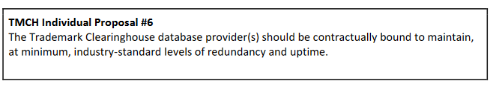

- If you wish to (a) propose changes to TMCH Individual Proposal #6; and/or (b) provide a rationale for your response, please do so here.

TMCH Individual Proposal #7
Please find the link to this Individual Proposal and its context here: https://community.icann.org/x/DiKJBw

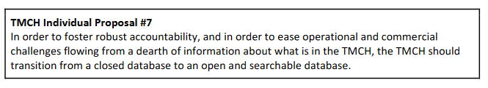
- Please choose one of the following responses for TMCH Individual Proposal #7:

Mark only one oval.

Support Proposal as written
Support Proposal concept with minor change Significant change required
Do not support Proposal No opinion

- If you wish to (a) propose changes to TMCH Individual Proposal #7; and/or (b) provide a rationale for your response, please do so here.

This one is a no-brainer. The TMCH was written to be an open database with its contents reviewable by the public and by potential registrants seeking to explore open and available domain names. Further, trademark in the vast majority of countries in the world are open and public – and designed that way to provide notice of the trademark claims. Trademarks should not be rendered secret by virtue of being added to the TMCH database.

Further, the ICANN Community should be able to review an open and public TMCH database as a way of overseeing this important function.

Save Your Progress

- Do you want to save your progress and quit for now? You will be able to return to the form to complete at a later time.
Mark only one oval.

Yes
No, I wish to continue to the next section

Section 10: Overarching Charter Questions
- The Working Group’s Charter includes several general, overarching questions as well as a number of additional questions that the Working Group is expected to address at the conclusion of Phase 1 or Phase 2 of its work, as appropriate.

- The Working Group invites community input on three (3) general and three (3) additional overarching Charter questions, which may help inform the Working Group's overall work toward the Final Report.

- General Overarching Charter #Q1. Do the RPMs collectively fulfil the objectives for their creation, namely “to provide trademark holders with either preventative or curative protections against cybersquatting and other abusive uses of their legally-recognized trademarks? In other words, have all the RPMs, in the aggregate, been sufficient to meet their objectives or do new or additional mechanisms, or changes to existing RPMs, need to be developed?

The RPMs overshoot their objectiosn by providing with trademark owners with protections broader than anticipated and a secret database of TMCH registrations. New RPMs do not need to be created; existing mechanisms need to be rolled back to original specifications and new oversight mechanisms must be added.

- General Overarching Charter #Q2a. Should any of the New gTLD Program RPMs (such as the URS), like the UDRP, be Consensus Policies applicable to all gTLDs?

No, the URS has no reason or rationale to be made applicable to all gTLDs. Like the Sunrise Period and the TM Claims Notice, the URS was designed to be part of special protections in a period of the roll-out of multiple new gTLDs. The legacy gTLDs, particular .com,.org and .net rolled out over 30 years ago. There is no need for special protection in these legacy gTLDs and no proof that the existing protections, especially the UDRP, are not properly tailored for issues that arise in them.

- General Overarching Charter #Q2b. If so, what are the transitional issues that would have to be dealt with as a consequence?

` No transitional issue as new gTLD RPMs for legacy gTLDs are not consensus policy.

- General Overarching Charter #Q3a. Will changes to one RPM need to be offset by concomitant changes to the others?

Yes, if we make the URS more powerful through many individual proposals above, it will have a profound and unpredictable impact on the UDRP – and the UDRP has worked well and in a predictable manner for the last 20 years. Such a disruption has not been anticipated or planned for by the WG and would be highly disruptive to the global DNS.

- General Overarching Charter #Q3b. If so, to what extent?

- Additional Overarching Charter #Q1. Do the RPMs adequately address issues of registrant protection (such as freedom of expression and fair use)?

No, RPMs do not adequately address or protect registrants and freedom of expression and fair use have suffered greatly through the misinterpreatation and mis-implemenation of many aspects of the New gTLD program. The secrecy of the TMCH dtabase is a bar to registrants who want to research and “clear” their future trademarks and domain names by checking those who are using them and in what categories of goods and services their use exists. Not attaching the Sunrise period to the categories of goods and services of the trademark owner gives the trademark owner the ability to register brands in gTLDs far beyond their trademark rights, and depriving good faith and fair use potential registrants of the same registrations.

Finally, the TM Claims notice has a clear and broad chilling effect which scares off legitimate users of common words and names.

- Additional Overarching Charter #Q2. Is the recent and strong ICANN work seeking to understand and incorporate Human Rights into the policy considerations of ICANN relevant to the UDRP or any of the RPMs?

- Additional Overarching Charter #Q3. How can costs be lowered so end users can easily access RPMs?

Costs can be lowered for end users and registrants by allowing the TMCH to be open and public – a place to easily and quickly search it as part of ordinary research in preparation for registering domain names and trademarks.

Save Your Progress

- Do you want to save your progress and quit for now? You will be able to return to the form to complete at a later time.
Mark only one oval.

Yes
No, I wish to continue to the next section

Section 11: Other Comments & Submission

- Are there any additional recommendations that you believe the Working Group should consider making? If yes, please provide details below.

The RPMs should be set back to their original scope and implementation details should be squared with the original language of the RPMs. The TMCH database should be open and public for research and review, design marks and GIs should not accepted. Such changes would be consistent with the limits of trademarks (a principle of the new gTLD rules), nominative fair use and the balancing of the rights of many different domain name and Internet users.

No new RPMs should be added as they would break the balance the WG and ICANN Community are trying to achieve among commercial and noncommercial registrants, and current and future trademark owners.

- Are there any other comments or issues you would like to raise pertaining to the Initial Report? If yes, please enter your comments here. If applicable, please specify the section or page number in the Initial Report to which your comments refer.

Yes, it should be agreed that all new gTLD should be bound to the RPMs as agreed by the WG, the GNSO Council and ICANN Board. After the extensive debates, over four years in this WG alone, the RPMs are as fair and balanced as we can make them. Registries should not be free to add additional RPMs, including those rejected by current and prior ICANN Working Groups at their discretion and catering to only one group of interests. As registrants are bound by these policies so too must registries be bound – and limited to – these RPMs as written.

Save Your Progress

This content is neither created nor endorsed by Google.

Forms

