Navigating your way at ICANN: Joint NCSG-At-Large outreach
ICANN 62, Panama, Tuesday 26th June 2018, 9:00-10:15 & 10:30-12:00 - Salon 9
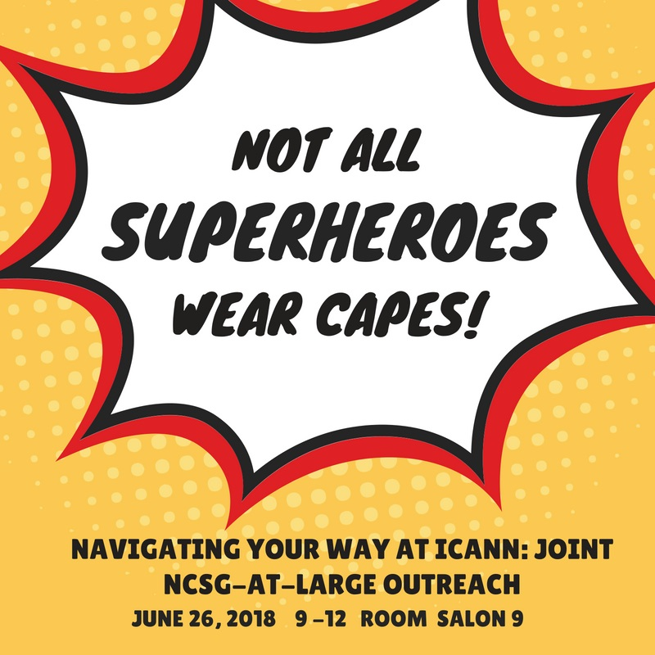

Agenda and resource persons:

AGENDA
(Moderators: Tatiana Tropina and Olivier Crépin-Leblond)
PART 1 - 09:00 - 09:30
1) Swimming through the acronym sea: Introduction to ICANN, NCUC, NPOC, NCSG and At-Large: (30 minutes)
- NCSG, its governance and its constituencies (ncuc, npoc) (Welcoming - Bruna Martins, Joan Kerr, Farzaneh Badii - remotely) (10 min)
- What is At-Large and how is it governed? (Alan Greenberg) (7 min)
- NCSG and At-Large: vive la différence! (Milton Mueller and Olivier Crépin-Leblond) (10 min)
- What NCSG and At-Large do together (Olivier Crépin-Leblond and Tatiana Tropina) (3 min)

PART 2 - 09:30 - 11:05
2) Advice or policy? What we are working on.

Issue 1: GDPR (Holly Raiche and Ayden Férdeline)
- Miseries and mysteries of GDPR compliance: “then” and “now” (10 min)
- The clock is ticking: 525 600 minutes for expedited policy development process (10 min)

Issue 2: New gTLD Subsequent procedures (Robin Gross + Cheryl Langdon-Orr)
- Geo names at New gTLD Subsequent Procedures Work Track 5: are cities’ names owned by the governments? (20 min)

Approx 10:10: Coffee Break

10:30 restart
Issue 3: Human Rights (Collin Kurre + Bastiaan Goslings (tbc))
- Accountability developments: Human Rights Issues pre- and post IANA transition (5 min)
- Human Rights and ICANN -- waking the dormant bylaw (10 min).

Issue 4: Rights Protection Mechanisms (RPMs) & Dispute Resolutions (Martin Pablo Silva Valent + At-Large speaker (tbc)) (20 min)

PART 3 - 11:05 - 12:00
1) Your ICANN Global Positioning System (GPS): ways to get involved (20 min)
- Joining PDPs, WGs and other processes through NCSG and At-Large, capacity building programs @ NCSG and At-Large (Rafik Dammak + Sebastien Bachollet)
- Have your say: drafting a public comment (Rafik Dammak + Tijani Ben Jemaa)

2) 11:25 - 11:48 ICANN related Open Discussion

3) Maybe you are our next leadership? (12 minutes )
- Opportunities at NCSG (3 min - Louise Marie Hurel)
- Opportunities in At-Large (3 min - Sébastien Bachollet)
- Global Stakeholder Engagement at ICANN (3 min - Adam Peake)
- NomCom (3 min - Anriette Esterhuysen)

4) Wrap up (3 minutes)
- NCSG: (Louise Marie Hurel)
- At-Large: (tbc )

